实验报告
姓名：张立成 学号：10165102104 班级：16级计科
实验题目：正则矩形裁剪任意多边形对象 实验时间：2019.10.26

问题描述
实现正则矩形裁剪任意多边形对象的Sutherland-Hodgman算法

求解思路
裁剪的工具为一个正则矩形，按照Sutherland-Hodgman算法思想逐边裁剪，将可能的情况分为四种，然后依次判断裁剪对象多边形的边上两点与裁剪矩形的关系并按照相应规则保留点，每裁剪一次保留的多边形作为下一次裁剪的对象，最后一次裁剪后连接各保留点得到裁剪后的图形。
实验关键点一是判断多边形某条边对应着Sutherland-Hodgman算法中四种情况的哪一种，二是求交点

程序代码
裁剪代码
# 求矩形的横边与多边形某条边的交点
def calc_intersection_length(self, x0, y0, x1, y1, y_length):
# 多边形的边是平行于x轴的
if y0 == y1:
return
x = x0 + (y_length - y0) * (x1 - x0) / (y1 - y0)
return x, y_length

# 求矩形的竖边与多边形某条边的交点
def calc_intersection_width(self, x0, y0, x1, y1, x_width):
# 多边形的边是平行于y轴的
if x0 == x1:
return
y = y0 + (x_width - x0) * (y1 - y0) / (x1 - x0)
return x_width, y

def clip(self, x0, y0, x1, y1):
retained_points = []
for i in range(len(self.vertexes)):
k = (i + 1) % (len(self.vertexes))
sx = self.vertexes[i][0]
sy = self.vertexes[i][1]
px = self.vertexes[k][0]
py = self.vertexes[k][1]

# 通过向量叉积分别判断点s, p是否在边界内侧
s_in = (x1 - x0) * (sy - y0) - (y1 - y0) * (sx - x0)
p_in = (x1 - x0) * (py - y0) - (y1 - y0) * (px - x0)
# 四种情况分别处理
# 1. 都在内侧，保留点p
if s_in >= 0 and p_in >= 0:
retained_points.append((px, py))
# 2. s在外侧，p在内侧，保留p和交点
elif s_in < 0 and p_in >= 0:
if x0 == x1: # 竖边
retained_points.append(self.calc_intersection_width(sx, sy, px, py, x0))
else: # 横边
retained_points.append(self.calc_intersection_length(sx, sy, px, py, y0))
retained_points.append((px, py))
# 3. s在内侧，p在外侧，保留交点
elif s_in >= 0 and p_in < 0:
if x0 == x1: # 竖边
retained_points.append(self.calc_intersection_width(sx, sy, px, py, x0))
else: # 横边
retained_points.append(self.calc_intersection_length(sx, sy, px, py, y0))
# 4. 都在外侧，不保留
else:
pass
# 本次保留的多边形作为下一次裁剪的裁剪对象
self.vertexes = retained_points

def sh_clip(self):
# 按照正则矩形的下边开始逆时针依次进行裁剪
self.clip(self.clipWindowPoint1[0], self.clipWindowPoint1[1],
self.clipWindowPoint3[0], self.clipWindowPoint1[1])
self.clip(self.clipWindowPoint3[0], self.clipWindowPoint1[1],
self.clipWindowPoint3[0], self.clipWindowPoint3[1])
self.clip(self.clipWindowPoint3[0], self.clipWindowPoint3[1],
self.clipWindowPoint1[0], self.clipWindowPoint3[1])
self.clip(self.clipWindowPoint1[0], self.clipWindowPoint3[1],
self.clipWindowPoint1[0], self.clipWindowPoint1[1])
self.vertexes = [(int(x), int(y)) for x, y in self.vertexes]
self.join_vertexes(self.vertexes, Qt.red)

全部代码
import sys

from PyQt5 import QtCore
from PyQt5.QtWidgets import (QApplication, QWidget)
from PyQt5.QtGui import (QPainter, QPen, QPixmap)
from PyQt5.QtCore import Qt

class PolygonClip(QWidget):

def __init__(self):
super(PolygonClip, self).__init__()
self.resize(800, 600)
self.board = QPixmap(800, 600)
self.board.fill(Qt.white)
# setMouseTracking设置为False，否则不按下鼠标时也会跟踪鼠标事件
self.setMouseTracking(False)
self.painter = QPainter()
# 设置起点和终点，并设置标志位以控制打点
self.vertexes = []
self.polygon_drawn = False
# 裁剪窗口的左上角和右下角两点用以确定矩形
self.clipWindowPoint1 = (0, 0)
self.isDrawPoint1 = False
self.clipWindowPoint3 = (0, 0)
self.isDrawPoint3 = False

def paintEvent(self, paintEvent):
self.painter.begin(self)
self.painter.drawPixmap(0, 0, self.board)
self.painter.end()

def paintPoint(self, x, y, color):
self.painter.begin(self.board)
self.painter.setPen(QPen(color, 6))
self.painter.drawPoint(x, y)
self.painter.end()
self.update()

def draw_rectangle(self):
clipWindowPoint2 = (self.clipWindowPoint3[0], self.clipWindowPoint1[1])
clipWindowPoint4 = (self.clipWindowPoint1[0], self.clipWindowPoint3[1])
self.bresenham_drawline(self.clipWindowPoint1[0], self.clipWindowPoint1[1],
clipWindowPoint2[0], clipWindowPoint2[1], Qt.blue)
self.bresenham_drawline(clipWindowPoint2[0], clipWindowPoint2[1],
self.clipWindowPoint3[0], self.clipWindowPoint3[1], Qt.blue)
self.bresenham_drawline(self.clipWindowPoint3[0], self.clipWindowPoint3[1],
clipWindowPoint4[0], clipWindowPoint4[1], Qt.blue)
self.bresenham_drawline(clipWindowPoint4[0], clipWindowPoint4[1],
self.clipWindowPoint1[0], self.clipWindowPoint1[1], Qt.blue)

def join_vertexes(self, vertexes, color):
if len(vertexes) < 3:
return
else:
# 依次连接各点
for i in range(len(vertexes) - 1):
self.bresenham_drawline(vertexes[i][0], vertexes[i][1], vertexes[i + 1][0],
vertexes[i + 1][1], color)
# 连接第一个点和最后一个点
self.bresenham_drawline(vertexes[0][0], vertexes[0][1], vertexes[-1][0],
vertexes[-1][1], color)

def mousePressEvent(self, event):
x = event.pos().x()
y = event.pos().y()
if event.buttons() == QtCore.Qt.LeftButton and not self.polygon_drawn: # 左键按下
self.vertexes.append((x, y))
self.paintPoint(x, y, Qt.black)
elif event.buttons() == QtCore.Qt.RightButton: # 如果点击的是右键，则通过两点绘制正则矩形作为裁剪窗口
if not self.isDrawPoint1:
self.clipWindowPoint1 = (x, y)
self.isDrawPoint1 = True
self.paintPoint(x, y, Qt.blue)
elif not self.isDrawPoint3:
self.clipWindowPoint3 = (x, y)
self.isDrawPoint3 = True
self.paintPoint(x, y, Qt.blue)
else:
self.draw_rectangle()
self.isDrawPoint1 = False
self.isDrawPoint3 = False
else: # 点击其他键（一般是中键）来绘制多边形
self.join_vertexes(self.vertexes, Qt.black)
self.polygon_drawn = True

def mouseDoubleClickEvent(self, event):
if event.buttons() == QtCore.Qt.RightButton:
self.board.fill(Qt.white)
self.update()
# 回到初始状态
self.vertexes.clear()
self.polygon_drawn = False
self.clipWindowPoint1 = (0, 0)
self.isDrawPoint1 = False
self.clipWindowPoint3 = (0, 0)
self.isDrawPoint3 = False
elif event.buttons() == QtCore.Qt.LeftButton:
self.sh_clip()
else:
pass

# 求矩形的横边与多边形某条边的交点
def calc_intersection_length(self, x0, y0, x1, y1, y_length):
# 多边形的边是平行于x轴的
if y0 == y1:
return
x = x0 + (y_length - y0) * (x1 - x0) / (y1 - y0)
return x, y_length

# 求矩形的竖边与多边形某条边的交点
def calc_intersection_width(self, x0, y0, x1, y1, x_width):
# 多边形的边是平行于y轴的
if x0 == x1:
return
y = y0 + (x_width - x0) * (y1 - y0) / (x1 - x0)
return x_width, y

def clip(self, x0, y0, x1, y1):
retained_points = []
for i in range(len(self.vertexes)):
k = (i + 1) % (len(self.vertexes))
sx = self.vertexes[i][0]
sy = self.vertexes[i][1]
px = self.vertexes[k][0]
py = self.vertexes[k][1]

# 通过向量叉积分别判断点s, p是否在边界内侧
s_in = (x1 - x0) * (sy - y0) - (y1 - y0) * (sx - x0)
p_in = (x1 - x0) * (py - y0) - (y1 - y0) * (px - x0)
# 四种情况分别处理
# 1. 都在内侧，保留点p
if s_in >= 0 and p_in >= 0:
retained_points.append((px, py))
# 2. s在外侧，p在内侧，保留p和交点
elif s_in < 0 and p_in >= 0:
if x0 == x1: # 竖边
retained_points.append(self.calc_intersection_width(sx, sy, px, py, x0))
else: # 横边
retained_points.append(self.calc_intersection_length(sx, sy, px, py, y0))
retained_points.append((px, py))
# 3. s在内侧，p在外侧，保留交点
elif s_in >= 0 and p_in < 0:
if x0 == x1: # 竖边
retained_points.append(self.calc_intersection_width(sx, sy, px, py, x0))
else: # 横边
retained_points.append(self.calc_intersection_length(sx, sy, px, py, y0))
# 4. 都在外侧，不保留
else:
pass
# 本次保留的多边形作为下一次裁剪的裁剪对象
self.vertexes = retained_points

def sh_clip(self):
# 按照正则矩形的下边开始逆时针依次进行裁剪
self.clip(self.clipWindowPoint1[0], self.clipWindowPoint1[1],
self.clipWindowPoint3[0], self.clipWindowPoint1[1])
self.clip(self.clipWindowPoint3[0], self.clipWindowPoint1[1],
self.clipWindowPoint3[0], self.clipWindowPoint3[1])
self.clip(self.clipWindowPoint3[0], self.clipWindowPoint3[1],
self.clipWindowPoint1[0], self.clipWindowPoint3[1])
self.clip(self.clipWindowPoint1[0], self.clipWindowPoint3[1],
self.clipWindowPoint1[0], self.clipWindowPoint1[1])
self.vertexes = [(int(x), int(y)) for x, y in self.vertexes]
self.join_vertexes(self.vertexes, Qt.red)

def bresenham_drawline(self, x0, y0, x1, y1, color):
dx = abs(x1 - x0)
dy = abs(y1 - y0)
x = x0
y = y0
# 通过两点的位置关系和斜率区分不同情况
if x1 > x0:
step_x = 1
else:
step_x = -1
if y1 > y0:
step_y = 1
else:
step_y = -1
if dy > dx:
# 斜率绝对值大于1，交换dx, dy再代入公式，并记录交换的标志位
tmp = dx
dx = dy
dy = tmp
flag_change = True
else:
flag_change = False

delta = 2 * dy - dx
for i in range(1, dx + 1):
# 调用封装好的画点函数画点
self.paintPoint(x, y, color)
if delta >= 0:
if flag_change:
x += step_x
else:
y += step_y
delta -= 2 * dx
if flag_change:
y += step_y
else:
x += step_x
delta += 2 * dy

if __name__ == "__main__":
app = QApplication(sys.argv)
polygon_pyqt = PolygonClip()
polygon_pyqt.show()
app.exec_()

实验结果
- 画多边形（黑色线表示）
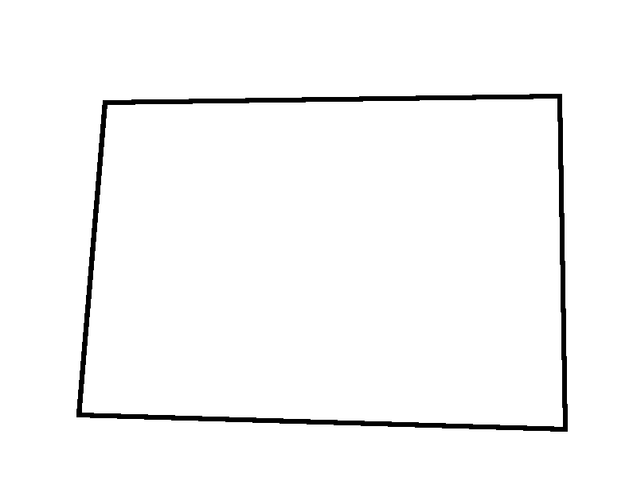
- 画裁剪窗口（蓝色线表示）
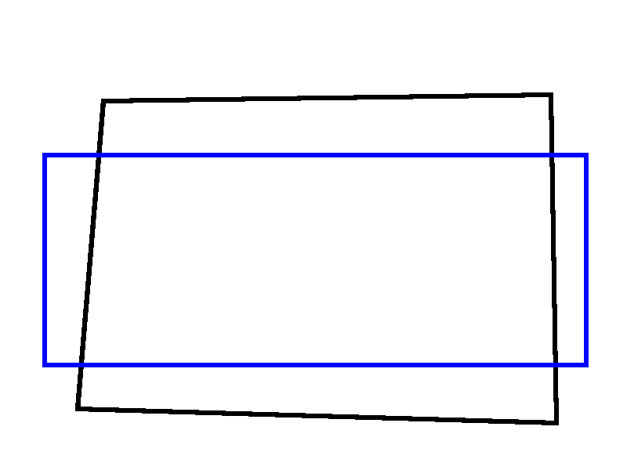
- 裁剪（红色线表示）
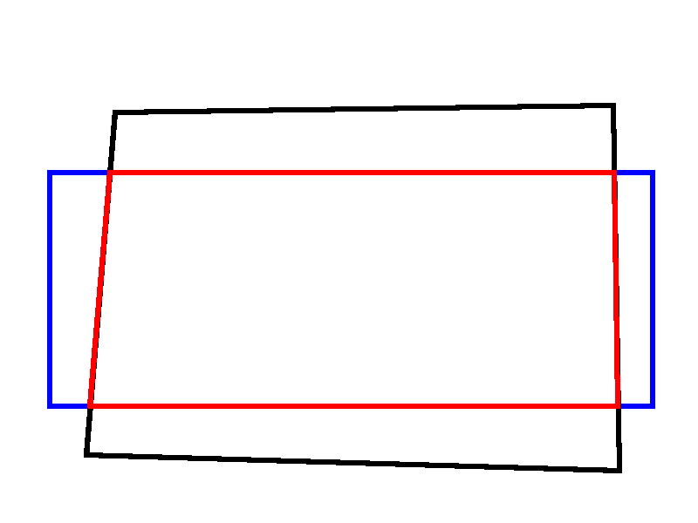
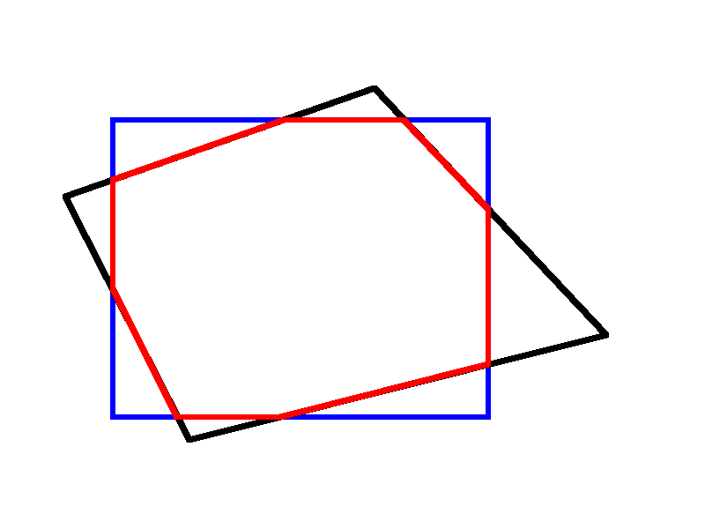
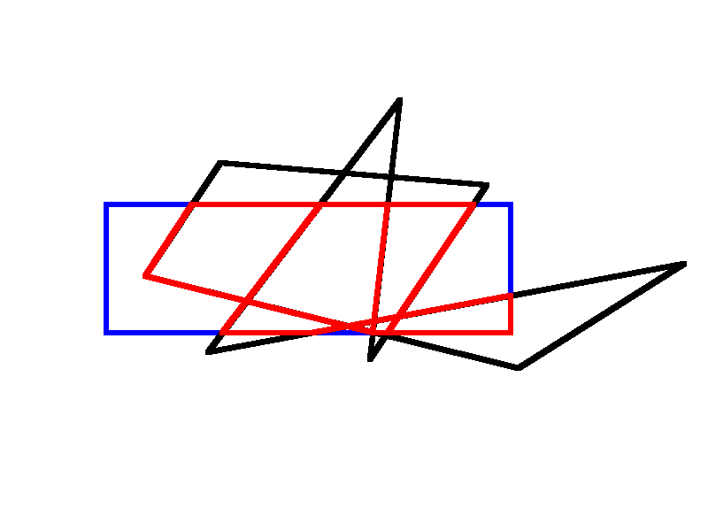
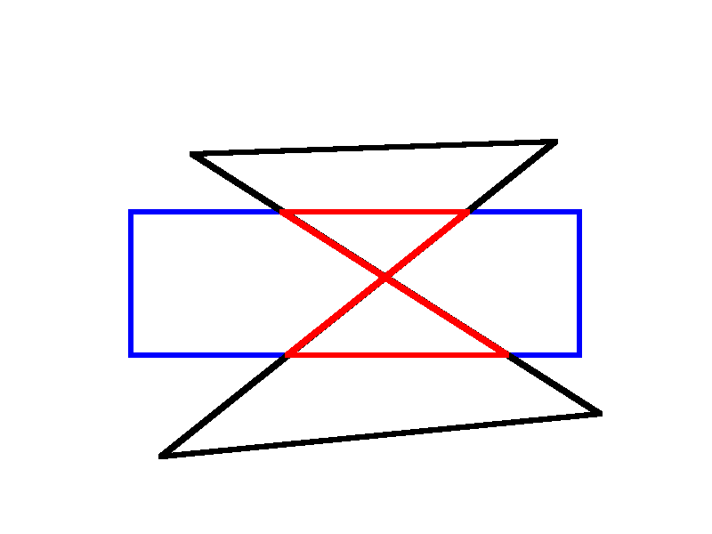

实验心得
有了比较明确的算法，执行起来并不难，按照顺时针的顺序依次将正则矩形各边作为裁剪边，裁剪一次后的多边形作为下个边裁剪的对象，裁剪过程是：依次遍历多边形各边，判断点S、点P是否在窗口内侧，分为四种情况分别处理，最后一个边裁剪完就得到了最终保留下来的各点，连接各点后得到了裁剪后的多边形。有一个技巧是使用向量判断点是否在裁剪边的内侧，这样判断大大简化了计算复杂性。对于任意多边形作为裁剪窗口，实际上与本次实验的差异就在于求交点，因为本次实验固定了裁剪窗口为正则矩形，那么求交点时可以确定交点的x值或y值，如果改为任意多边形，则需要联立两条直线求交点，计算会复杂一些，但是整体的算法思想是一致的。

